PRAJYOTI NIKETAN COLLEGE

PUDUKAD-680 301

Govt. Aided & Affiliated to University of Calicut



DEPARTMENT OF ELECTRONICS
(2023-2026)

INDUSTRIAL VISIT REPORT:

ITI LIMITED (INDIAN TELEPHONE
INDUSTRIES) PALAKKAD

NAME:

REG NO:
DEPARTMENT OF ELECTRONICS

PRAJYOTI NIKETAN COLLEGE
PUDUKAD, THRISSUR-680301

CERTIFICATE

This is to certify that Mr/Mrs._____________________________________________, a student of B.Sc Electronics with at Prajyoti Niketan College, Pudukkad, has successfully completed the Industrial Visit to Indian Telephone Industries (ITI), Palakkad on 15th March 2025.
He /She has prepared and submitted this report based on the observations and knowledge gained during the industrial visit. This report is submitted as a part of the academic requirements of the B.Sc Electronics programme.

Place: Pudukkad
Date: ___________

Dr Jibish Mathew Dr. Uma Devi

Faculty Coordinator Head of the Department
Department of Electronics Department of Electronics
Signature: Signature:
DECLARATION

I hereby declare that the Industrial Visit Report titled “ ITI (INDIAN TELEPHONE
INDUSTRIES) Limited, Palakkad” is a record of the work carried out by me as part of the academic requirement of B.Sc Electronics at Prajyoti Niketan College, Pudukkad.
I further declare that this report has been prepared based on the observations and information collected during the industrial visit conducted on 15th March 2025, and it has not been submitted elsewhere for any other academic purpose.

Place: Pudukkad
Date: ___________

Name of the Student:
Register Number:

Signature:
ACKNOWLEDGEMENT

First and foremost, I express my sincere thanks to the Almighty God for His blessings and guidance in successfully completing this Industrial Visit Report.
I express my deep gratitude to our Principal, Prof. Dr. Simi Varghese, Prajyoti Niketan College, Pudukkad, for providing the opportunity to undertake this industrial visit as part of our academic curriculum.
I also extend my heartfelt thanks to our Head of the Department, Dr. Umadevi K S, Department of Electronics, for her valuable support and encouragement.
I would like to express my sincere gratitude to our faculty members Mr. Joseph P. P, Mrs. Seethal Sreedharan, and our Lab Instructor Mrs.Susmy Johnson for their guidance and support during the industrial visit.
Finally, I express my thanks to the officials and staff of ITI Limited, Palakkad, for providing us with valuable information and for making the industrial visit informative and successful.

ABSTRACT

Industrial visits play an important role in bridging the gap between theoretical knowledge and practical industrial applications. The industrial visit to ITI Limited, Palakkad, conducted on 15th March 2025, provided students with an opportunity to gain practical exposure to the functioning of a telecommunications manufacturing industry.
ITI Limited is one of India's leading public sector enterprises engaged in the manufacturing of telecommunication equipment and electronic communication systems. The Palakkad unit, established in 1976, specializes in the production of electronic switching systems, digital switches, and trunk exchanges used in communication networks.
During the visit, students observed the industrial environment, manufacturing processes, and the various technologies used in electronic communication systems. The visit also provided insights into industrial safety practices, quality control procedures, and the role of advanced electronic systems in modern communication infrastructure.
This industrial visit helped students enhance their understanding of electronics and telecommunications while providing valuable exposure to real-world industrial operations.

TABLE OF CONTENTS
Sl. No | Title | Page No
1 | Introduction | 1
2 | Objectives of the Industrial Visit | 3
3 | About the Industry | 6
4 | Working of the Industry | 8
5 | Observations | 11
6 | Learning Outcomes | 14
7 | Conclusion | 16

INTRODUCTION

Industrial visits are considered an important part of technical education, as they provide students with an opportunity to gain practical knowledge about industrial processes and working environments. Classroom learning mainly focuses on theoretical concepts, while industrial visits help students understand how these concepts are applied in real-world situations. Through industrial visits, students are able to observe the functioning of industries, the use of machinery, the organisation of production processes, and the importance of teamwork in achieving industrial goals.
The main objective of an industrial visit is to bridge the gap between theoretical knowledge and practical experience. It helps students gain exposure to modern technologies, industrial practices, and safety standards followed in industries. Industrial visits also enable students to interact with industry professionals and understand the challenges and opportunities present in the industrial sector. Such experiences help students develop a broader perspective about their field of study and prepare them for future professional careers.
For students of Electronics, industrial visits are particularly important because the field involves various practical applications in industries such as telecommunications, electronics manufacturing, automation, and embedded systems. Observing industrial equipment and processes helps students understand how electronic components, circuits, and systems are used in real-life industrial operations.
As part of our academic curriculum, an industrial visit was organised to ITI Limited, Palakkad, on 15th March 2025. ITI Limited (Indian Telephone Industries Limited) is one of the leading public sector enterprises in India engaged in the manufacturing of telecommunication equipment and electronic communication systems. The Palakkad unit of ITI Limited is one among the five major manufacturing plants of the company and was established in the year 1976.

The ITI Palakkad plant primarily focuses on the manufacturing of Electronic Switching Systems (ESS), large digital switches, and trunk exchanges used in telecommunication networks. These systems play a crucial role in establishing communication between different locations and ensuring the smooth transmission of voice and data across networks. The industry is equipped with modern facilities and advanced technologies that support the production and testing of telecommunication equipment.
During the industrial visit, students were able to observe various sections of the manufacturing unit and gain knowledge about the working of electronic switching systems and other communication technologies. The technical staff of the organization explained the different processes involved in manufacturing, assembling, and testing telecommunication equipment. Students were also introduced to the importance of quality control, safety measures, and proper maintenance of industrial equipment.
The visit provided valuable insights into the functioning of a telecommunications industry and helped students understand the role of electronics in modern communication systems. It also gave students an opportunity to see how theoretical concepts learned in the classroom are applied in real industrial environments. This experience was highly informative and helped enhance the practical knowledge and technical understanding of students.

Overall, the industrial visit to ITI Limited, Palakkad was a meaningful learning experience that allowed students to gain practical exposure to industrial operations, modern telecommunication systems, and professional work environments. Such visits play an important role in shaping the technical knowledge and professional outlook of students pursuing careers in electronics and related fields.

OBJECTIVES OF THE INDUSTRIAL VISIT
The industrial visit to ITI Limited, Palakkad was organized with the aim of providing students with practical exposure to the working environment of an electronics and telecommunications industry. Industrial visits play an important role in helping students understand how theoretical concepts learned in the classroom are applied in real industrial situations. The visit helped students gain valuable insights into industrial operations, advanced technologies, and professional work environments. The main objectives of the industrial visit are explained below.
1. To understand the industrial working environment
One of the main objectives of the industrial visit was to familiarise students with the real working environment of an industry. Industries operate in a structured and organized manner where different departments work together to achieve production goals. By visiting the industry, students were able to observe the work culture, organizational structure, and coordination among employees. This helped students understand how industries function in a professional setting.
2. To bridge the gap between theoretical and practical knowledge
Students learn many theoretical concepts related to electronics, telecommunications, and communication systems in the classroom. However, practical exposure is necessary to fully understand these concepts. The industrial visit provided an opportunity for students to observe how these theoretical principles are applied in the manufacturing and testing of telecommunication equipment. This helped students relate classroom learning with real-world industrial applications.
3. To observe modern industrial machinery and equipment
Another important objective of the industrial visit was to observe the machines and equipment used in the industry. At ITI Limited, students were introduced to various industrial tools, electronic systems, and telecommunication equipment used in manufacturing processes. Observing these machines helped students understand how modern industries use advanced technologies to improve productivity and efficiency.

4. To study the manufacturing and assembly processes
The visit aimed to provide students with knowledge about the manufacturing and assembly processes involved in electronic communication systems. Students were able to learn about different stages such as component assembly, circuit board production, system integration, and testing procedures. Understanding these processes helped students gain a clear idea of how electronic products are manufactured in an industrial setup.
5. To understand electronic switching systems and communication technology
ITI Limited is known for the production of electronic switching systems and telecommunication equipment. One of the objectives of the visit was to understand how these systems work and how they are used in communication networks. Students were introduced to digital switches and trunk exchanges that play an important role in connecting communication networks. This helped students understand the significance of electronics in modern telecommunications.
6. To learn about industrial safety practices
Safety is an essential aspect of any industrial environment. During the visit, students were able to observe the safety measures followed within the industry. The staff explained the importance of maintaining safety standards while operating machines and handling electronic equipment. Learning about these safety procedures helped students understand how industries protect workers and maintain a safe working environment.

7. To understand quality control and testing procedures
Industries must ensure that the products they manufacture meet required standards and function correctly. Another objective of the visit was to understand how industries maintain quality control. Students were introduced to various testing procedures used to verify the performance and reliability of telecommunication equipment. This helped students appreciate the importance of quality assurance in industrial production.

8. To gain exposure to professional career opportunities
The industrial visit also aimed to provide students with an understanding of career opportunities available in the electronics and telecommunications industries. By interacting with technical staff and observing industrial operations, students gained insights into the roles and responsibilities of engineers and technicians working in such industries. This exposure helped students develop a better understanding of their future career prospects.

In conclusion, the industrial visit to ITI Limited, Palakkad was organized with the objective of providing students with practical knowledge, industrial exposure, and a better understanding of how electronics and communication systems are developed and used in real-world applications. The visit helped students enhance their technical knowledge and gain valuable insights into the functioning of a telecommunications industry.

ABOUT THE INDUSTRY
ITI Limited (Indian Telephone Industries Limited) is one of the major public sector companies in India involved in the manufacturing of telecommunication and electronic equipment. The company was established in the year 1948 with the aim of supporting the development of India's communication systems. Over the years, ITI Limited has played an important role in building and maintaining the country's telecommunication infrastructure.


The headquarters of ITI Limited is located in Bengaluru, Karnataka. The company has several manufacturing units across India including Bengaluru, Naini, Rae Bareli, Mankapur, and Palakkad. Among these, the ITI Palakkad unit is one of the important manufacturing plants of the company.
The ITI Limited Palakkad plant was established in the year 1976. It is located in the Kanjikode Industrial Area of Palakkad district in Kerala. The plant mainly focuses on the manufacturing and assembly of electronic systems and telecommunication equipment.
The industry works with different electronic components such as resistors, capacitors, integrated circuits (ICs), and microchips. These components are assembled on Printed Circuit Boards (PCBs) to create electronic circuits. These circuit boards form the base of many electronic devices and communication systems.
During the industrial visit, students were introduced to various electronic boards and modules used in communication equipment. The plant also works on the development and assembly of electronic devices and computing systems. One of the interesting products shown during the visit was compact laptop-like computing devices known as SMAASH laptops. These devices are used for specialized communication and operational purposes.

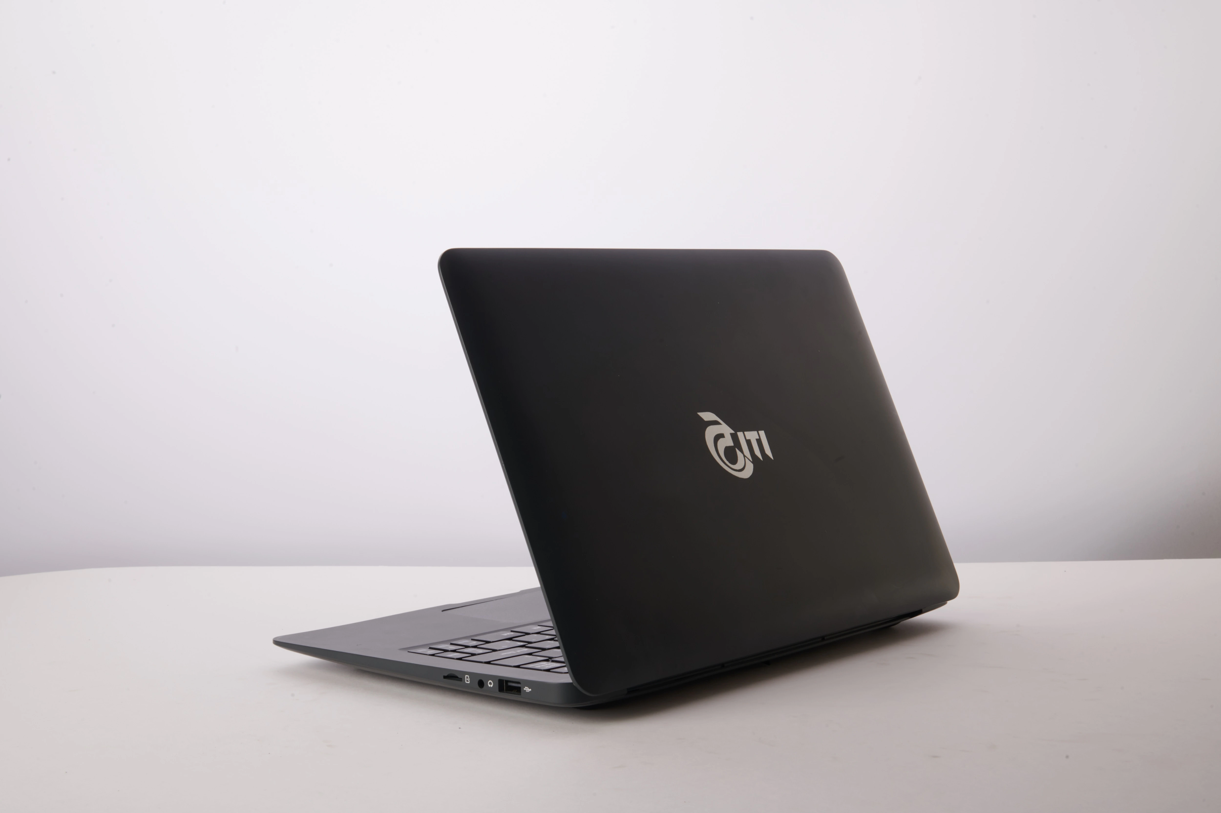
These laptop-type devices are designed for specific applications such as communication systems, technical operations, and other professional uses. The manufacturing process includes assembling circuit boards, installing electronic modules, and integrating different hardware components into the final device.
The ITI Palakkad unit has several sections for assembly, testing, and quality inspection. Skilled engineers and technicians work in different departments to ensure that the devices and communication systems are manufactured correctly and meet required standards.
The plant plays an important role in supporting India's electronics and telecommunications sectors. The industry also provides employment opportunities and contributes to technological development in the region.

WORKING OF THE INDUSTRY
The working process of ITI Limited Palakkad involves several stages such as electronic design, circuit assembly, device integration, testing, and quality control. Each stage is carefully carried out to ensure the proper functioning of electronic systems and devices.
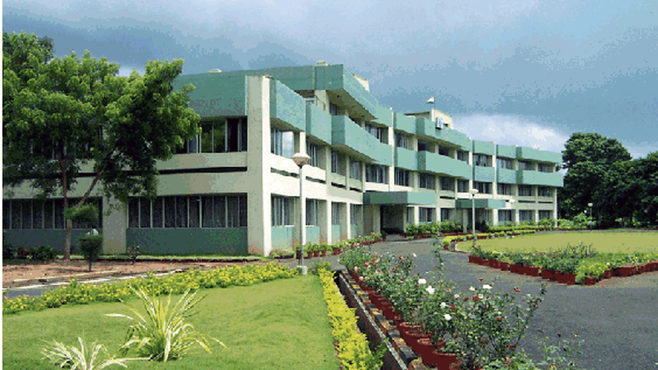

The process begins with the design of electronic circuits and communication systems. Engineers design the circuits and determine how different electronic components will be connected to perform specific functions.
After the design stage, the next step is the preparation of Printed Circuit Boards (PCBs). PCBs act as the base structure for electronic circuits. They contain conductive pathways that allow electrical signals to pass between different components.
Electronic components such as resistors, capacitors, microchips, and integrated circuits are mounted on the PCB. This process is called PCB assembly. The components are placed carefully and soldered onto the board to create a stable electrical connection.
Once the circuit boards are assembled, they are integrated into electronic modules and devices. These modules are then used to build larger communication systems and computing devices. During the industrial visit, students were able to observe different electronic boards used in communication equipment and laptop-type systems.
The assembled circuits and devices are then sent for testing. Testing is a very important stage in the production process because it ensures that the system works properly. Engineers use various electronic testing instruments to check the performance of the circuits and devices.
If any faults are found during testing, the devices are repaired and tested again. This ensures that only properly functioning products are delivered.
Quality control is also an important part of the industry. Every device and electronic system is inspected carefully before it is approved for use. This helps maintain high reliability and performance of the equipment produced in the plant.
The plant also follows proper safety and maintenance procedures. Workers are trained to handle electronic equipment carefully and follow safety guidelines while working with machines and electrical systems.
The industrial visit to ITI Limited Palakkad helped students understand how electronic circuits, communication systems, and computing devices such as specialized laptops are assembled and tested in a real industrial environment. The visit provided valuable practical knowledge about the functioning of an electronics manufacturing industry.

OBSERVATIONS
During the industrial visit to ITI Limited, Palakkad, several important observations were made regarding the functioning of the industry, the technologies used, and the work environment within the organization. The visit provided an opportunity to observe the practical aspects of telecommunication equipment manufacturing and industrial management.

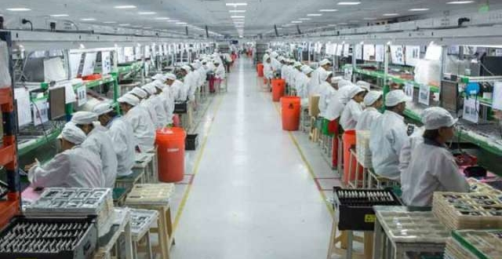
One of the most noticeable observations was the well-organized structure of the industrial plant. Different sections of the plant were arranged systematically for various processes such as assembly, testing, and quality inspection. Each department had specific responsibilities and worked in coordination to ensure smooth production.
Another important observation was the use of modern electronic equipment and advanced technologies in the manufacturing process. Various machines and tools were used for assembling electronic components and building telecommunication systems. The technicians and engineers handled these machines with precision and expertise to maintain product quality.
The plant also maintained strict quality control procedures at every stage of production. Components and electronic modules were carefully inspected before and after assembly to ensure that the final product met the required technical standards. This helped in maintaining reliability and efficiency in the telecommunication equipment manufactured by the company.
Safety measures were also clearly visible within the industry. Safety instructions and guidelines were displayed in different areas of the plant. Employees followed safety procedures while working with electrical equipment and machines. The importance of maintaining a safe working environment was emphasised by the staff during the visit.

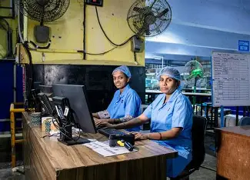
Another observation was the professionalism and discipline maintained by the employees. Workers followed a systematic work schedule and performed their tasks efficiently. Teamwork and coordination among the staff played a major role in maintaining productivity and smooth functioning of the plant.
The visit also helped in understanding the importance of telecommunications in modern society. The equipment manufactured by ITI Limited plays a vital role in establishing communication networks across the country. The systems developed in the plant help in connecting people and enabling communication services.
Overall, the industrial visit provided valuable insights into the working of a telecommunications manufacturing industry. The observations made during the visit helped students understand industrial operations, modern technologies, and the importance of quality and safety in manufacturing processes.

LEARNING OUTCOMES
The industrial visit to ITI Limited, Palakkad provided students with valuable learning experiences and practical exposure to the functioning of a telecommunications manufacturing industry. The visit helped students gain a deeper understanding of industrial operations and the practical applications of electronics in communication systems.

One of the major learning outcomes of the visit was the understanding of how theoretical concepts studied in the classroom are applied in real industrial environments. Students were able to see how electronic components and circuits are used in the development of telecommunication equipment and switching systems. This helped in strengthening the connection between theoretical knowledge and practical applications.
Another important learning outcome was gaining knowledge about the manufacturing and assembly processes involved in electronic communication systems. Students learned about the different stages of production such as component assembly, circuit board preparation, system integration, and testing procedures. Observing these processes provided a clear understanding of how electronic systems are developed in industries.
The visit also helped students understand the importance of electronic switching systems used in telecommunications networks. Students were introduced to digital switches and trunk exchanges that help in routing communication signals between different locations. Learning about these systems improved students’ understanding of how modern communication networks function.
Students also learned about the importance of quality control in industrial production. The industry follows strict quality assurance procedures to ensure that the products manufactured meet required standards and function properly. This helped students understand how industries maintain reliability and efficiency in their products.
Another valuable learning outcome was the awareness of industrial safety practices. Students observed the safety measures followed in the plant and learned about the importance of maintaining a safe working environment. Proper handling of machines, electrical equipment, and electronic systems was emphasized during the visit.
The industrial visit also provided students with an opportunity to understand the professional working culture of an industry. Observing the discipline, teamwork, and coordination among employees helped students gain insights into how industries operate efficiently.
Overall, the industrial visit to ITI Limited, Palakkad was a highly informative experience that enhanced students’ knowledge about electronics, telecommunications, and industrial operations. The visit helped students gain practical exposure and develop a better understanding of the technologies used in modern communication systems.

CONCLUSION
The industrial visit to ITI Limited, Palakkad, conducted on 15th March 2025, was a highly informative and valuable learning experience for the students. Industrial visits play an important role in technical education as they provide students with practical exposure to real industrial environments and help them understand the practical applications of theoretical concepts learned in the classroom.

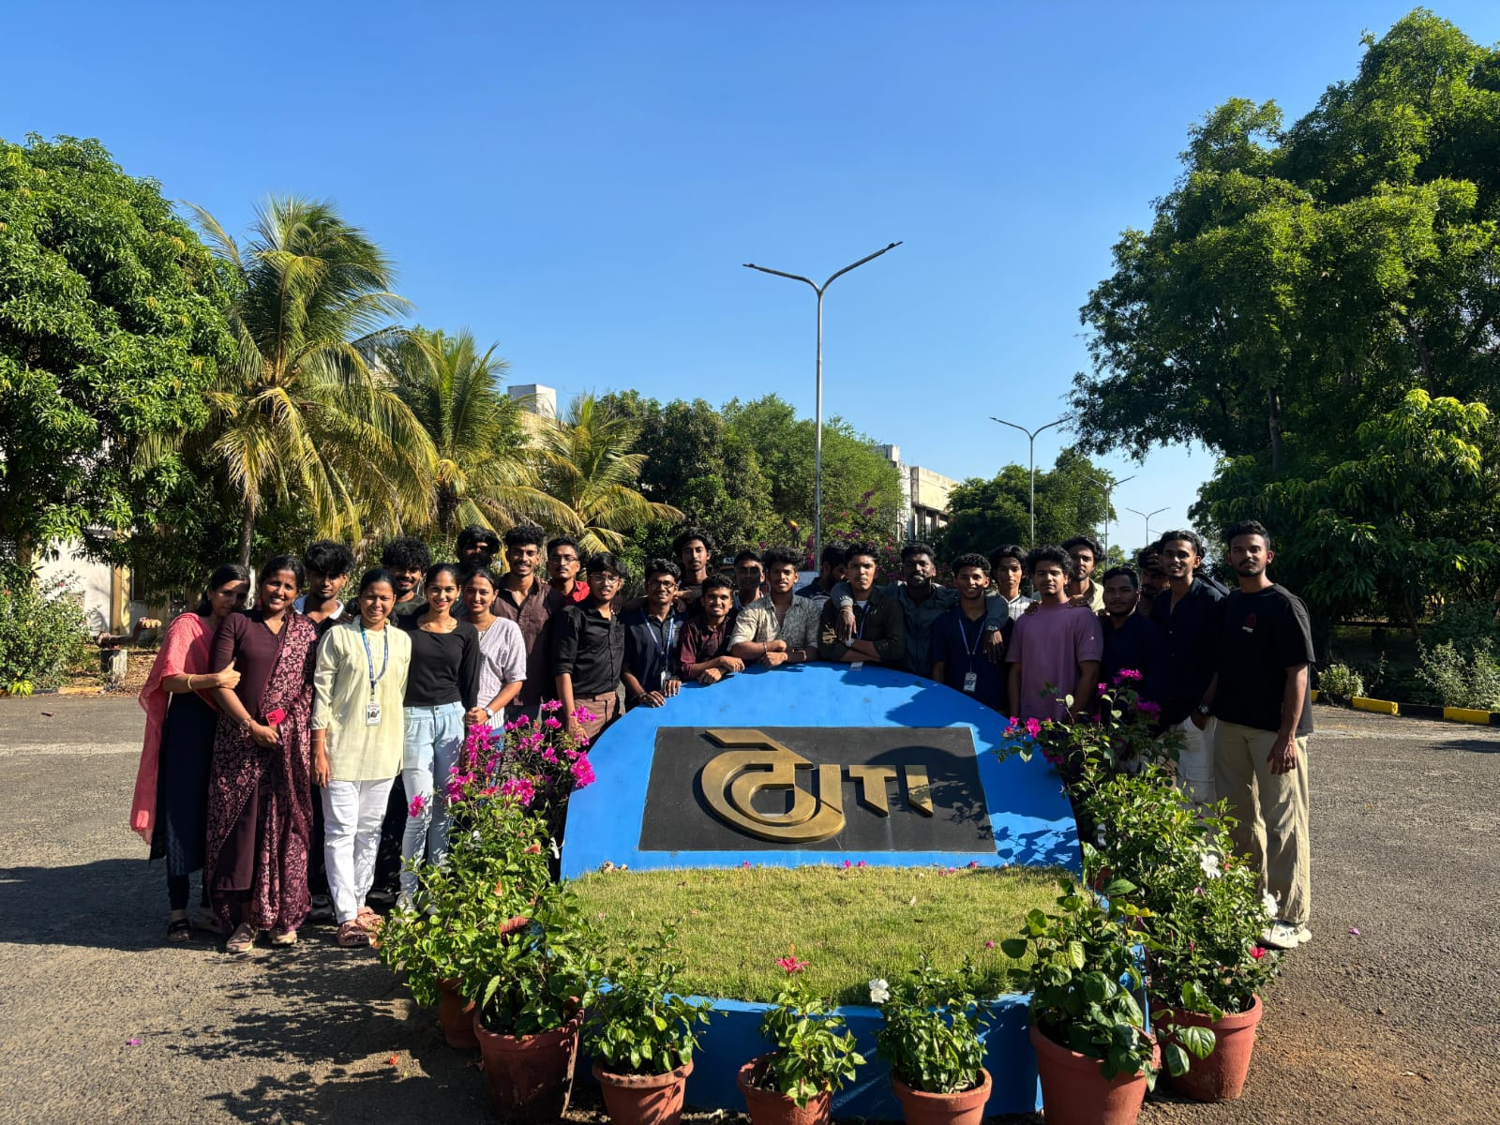
During the visit, students were able to observe the functioning of a telecommunications manufacturing industry and gain knowledge about the production and testing of telecommunication equipment. The visit provided insights into electronic switching systems, digital switches, and trunk exchanges used in modern communication networks. Observing these systems helped students understand how communication technologies are developed and implemented in real-world applications.
The visit also helped students understand the importance of quality control, safety procedures, and proper management in industrial operations. The organized working environment, advanced machinery, and professional work culture observed in the industry highlighted the importance of efficiency and teamwork in achieving industrial goals.
Another important benefit of the visit was the opportunity to interact with technical staff and learn about the roles and responsibilities of engineers and technicians working in the telecommunications sector. This interaction provided students with valuable insights into career opportunities in the electronics and communication industries.
Overall, the industrial visit to ITI Limited, Palakkad helped students gain practical knowledge, enhance their technical understanding, and develop a better perspective about industrial operations. Such visits are highly beneficial for students as they help bridge the gap between academic learning and real-world industrial practices. The experience gained from this visit will be helpful for students in their future academic and professional careers.

